Hardware Installation Guide

The Operations Team must follow the steps below

PRE-INSTALLATION:
- Technical Reconnaissance (scope site layout & choose cabinet locations)
- Plan the project (time-line, project lead, components needed, etc)
- Start a hardware requisition
- Order materials/components
- Reconcile procurement of materials with project needs
- Modify exiting hardware:
- Add holes for fans & wires
- Add block board to all cabinets covering the entire interior back wall of the cabinet

HOW TO CHOOSE CABINET LOCATIONS:

- Pick a central location for the Switchboard:
- Distance between cabinet & workstations should not be > 100m
- If distance between any 2 points exceed 100m = add another switchboard cabinet



Switch
Cabinet

- Choose a central location for the Server Cabinet:
- Needs to be in a well ventilated room, at least 1 window
- Room needs to be secure: windows with bars and door with locks

- Choose a well ventilated area for the Power cabinet:
- Location should be close to ECSOM distribution board & safe from theft and weather conditions
- For J2's, if greater than 10 workstations = + 1 Power Cabinet (a full back up system with 4 batteries)

CABINET DESIGNS:
1
2
3

Standard Design = 3 cabinets. Switchboard + Server + Power

Alternative Design = 2 cabinets. (Switchboard + Server) + Power

CABINET LAYOUT

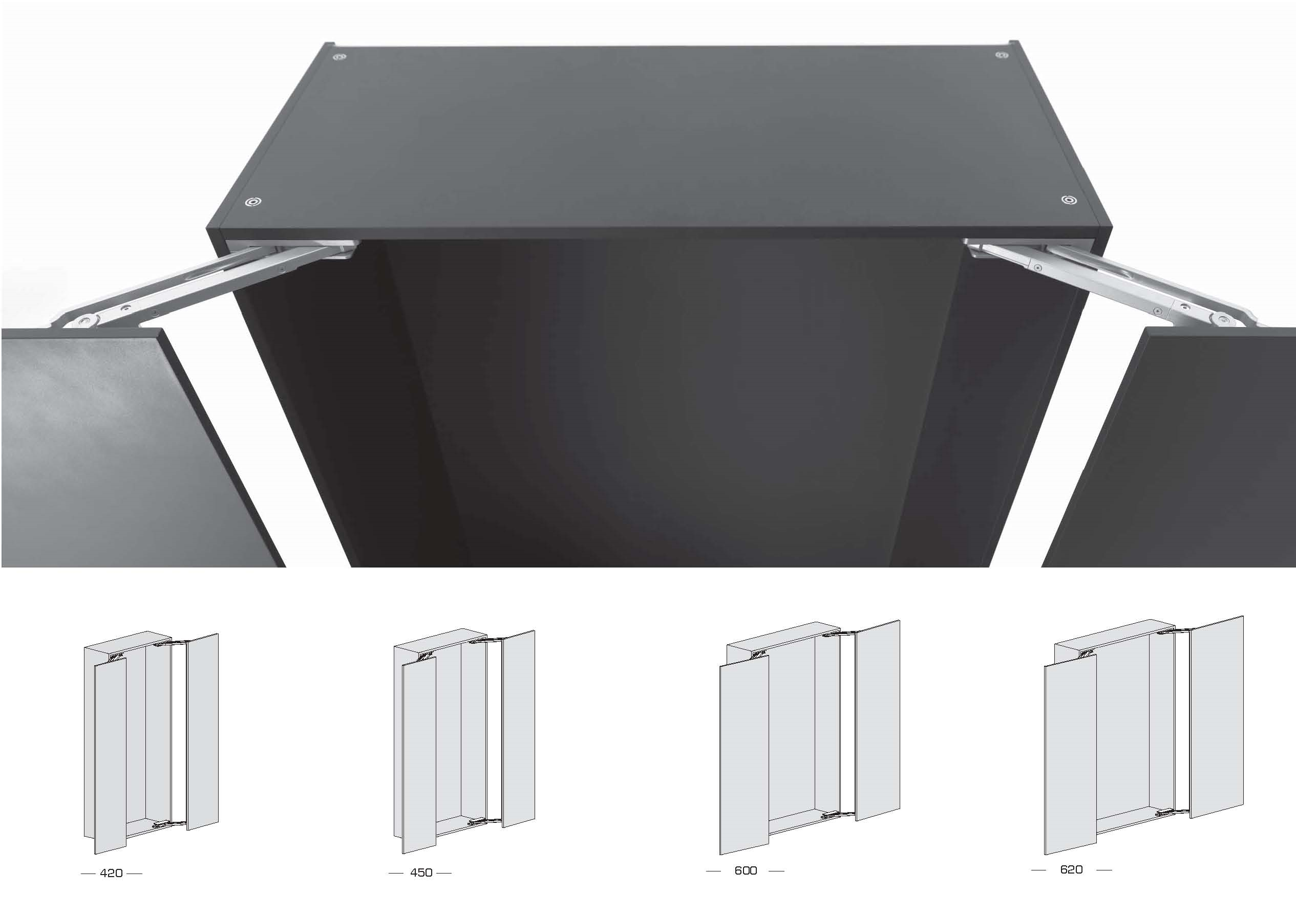

NOT

Correct Incorrect

STANDARD DESIGN
All cabinets in different rooms: see below

Switchboard + Server + Power
3
Server
Fan(air out)
LVD
Charger
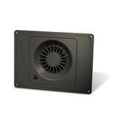
Power Connections

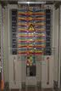
Shelf
Switch
4 Batteries
Power Connections
1
2
Voltage Monitor
Fan(air out)
Blockboard
Blockboard
Fan(air in)
Fan(air out)
Blockboard

ALTERNATIVE DESIGN

Server & Switchboard in the same cabinet stacked vertically on top of the Power Cabinet: see below
Server
Switch
Fan(air out)
+
Blockboard
1
Switchboard & Server
Power Connections
2
Voltage Monitor
Blockboard
Fan (air out)
LVD
3
Charger)
4 Batteries
Shelf
Power
Fan (air in)
Fan (air out)
Blockboard

DAY OF INSTALLATION

Should be done prior to Back Data Entry by Support & Deployment Team

Alternative Back Data Entry:The Support & Deployment Team connects touch-screens to a local server and ESCOM electricity, with a working hospital generator or Baobab generator, then migrate data later.

PRIOR TO DEPARTURE:
Use the “Hardware Check-list” to confirm you have all materials needed to bring to the site.

DAY 1: RUN WIRES & PIPES

- Install PVC pipe for power connections (power cables for 48 volts inside)
- Install PVC trunking (plastic covering) for Ethernet cables (connected to data socket)
- Terminate Ethernet cables
- Install data sockets (run cables to switchboard)

DAY 2: INSTALL CABINETS

- Install Server cabinet
- Install Switchboard cabinet
- Install Power back up cabinet

DAY 3: TEST

- Test Connectivity- use a laptop to test Ethernet connection to the site server (i.e. “ping” server IP addresses). Test point of care at each ward. Unsuccessful response = “host unreachable”

- Test Power Connections with volt multimeter to make sure 48 volts are coming from each power socket that is connected to the four batteries in the power cabinet.

- Install a data cable link (covered with PVC trunking) from the Baobab system to the HMIS system (i.e. their switchboard or computer in the HMIS office if the site does not have a network)

- Test connectivity between Baobab system & HMIS office (i.e. “ping” server IP address)

- If site has internet, configure Baobab server on site to access Baobab HQ server (“Cottonwood”)

SECURITY & SAFETY: FINAL CHECK

- All cabinets must have a padlock
- All rooms must be locked
- Label keys: 1 set of with HMIS Officer & 1 set at Baobab HQ in Operations Department key cabinet
- Every room with a power cabinet needs to have a fire extinguisher

Should not take more than 1 business week (5 days)

ENTER SUPPORT & DEPLOYMENT TEAM
Install Touch-screens
Run & Test Baobab module

OPERATIONS HARDWARE CHECKLIST | CHECK LIST FOR NEW SITE HW INSTALLATION
OPERATIONS HARDWARE CHECKLIST | TOOLS/ MATERIALS REQUIRED | QTY | CHECK
OPERATIONS HARDWARE CHECKLIST | Keys for server room & cabinets
OPERATIONS HARDWARE CHECKLIST | 110V AC Transformer
OPERATIONS HARDWARE CHECKLIST | 2.5mm earth wire
OPERATIONS HARDWARE CHECKLIST | 48V cooling fan
OPERATIONS HARDWARE CHECKLIST | Babble level
OPERATIONS HARDWARE CHECKLIST | Bag of cement
OPERATIONS HARDWARE CHECKLIST | Batteries
OPERATIONS HARDWARE CHECKLIST | Battery Charger
OPERATIONS HARDWARE CHECKLIST | Battery charger for drill machine
OPERATIONS HARDWARE CHECKLIST | Battery terminals
OPERATIONS HARDWARE CHECKLIST | Blockboard
OPERATIONS HARDWARE CHECKLIST | Builder's knife
OPERATIONS HARDWARE CHECKLIST | Circuit Breaker
OPERATIONS HARDWARE CHECKLIST | Computer server
OPERATIONS HARDWARE CHECKLIST | Draw wire
OPERATIONS HARDWARE CHECKLIST | Drill bits ( concrete, steel, wood bits)
OPERATIONS HARDWARE CHECKLIST | Drill machines (both electric & battery power)
OPERATIONS HARDWARE CHECKLIST | Electric hacksaw
OPERATIONS HARDWARE CHECKLIST | File
OPERATIONS HARDWARE CHECKLIST | Fish tape
OPERATIONS HARDWARE CHECKLIST | Hacksaw
OPERATIONS HARDWARE CHECKLIST | Hammer
OPERATIONS HARDWARE CHECKLIST | Hydrolic cutting machine
OPERATIONS HARDWARE CHECKLIST | Insulation tape
OPERATIONS HARDWARE CHECKLIST | Key for drill chunk
OPERATIONS HARDWARE CHECKLIST | Ladders
OPERATIONS HARDWARE CHECKLIST | LVD
OPERATIONS HARDWARE CHECKLIST | Multimeter
OPERATIONS HARDWARE CHECKLIST | Network Switch
OPERATIONS HARDWARE CHECKLIST | Padlocks for cabinets
OPERATIONS HARDWARE CHECKLIST | Plain bend
OPERATIONS HARDWARE CHECKLIST | Pliers
OPERATIONS HARDWARE CHECKLIST | Power Extension cord
OPERATIONS HARDWARE CHECKLIST | PVC coupling
OPERATIONS HARDWARE CHECKLIST | PVC Nipples
OPERATIONS HARDWARE CHECKLIST | PVC pipes (25mm,110mm,20mm)
OPERATIONS HARDWARE CHECKLIST | PVC pipes (25mm,110mm,20mm)
OPERATIONS HARDWARE CHECKLIST | PVC saddles
OPERATIONS HARDWARE CHECKLIST | PVC trunking
OPERATIONS HARDWARE CHECKLIST | RJ45 connectors
OPERATIONS HARDWARE CHECKLIST | RJ45 Crimping tool
OPERATIONS HARDWARE CHECKLIST | Router if necessary
OPERATIONS HARDWARE CHECKLIST | Screw drivers
OPERATIONS HARDWARE CHECKLIST | Screws, Nut & bolts
OPERATIONS HARDWARE CHECKLIST | Side Cutters
OPERATIONS HARDWARE CHECKLIST | Soldering station, Solder wire
OPERATIONS HARDWARE CHECKLIST | SW Mounting Bracket
OPERATIONS HARDWARE CHECKLIST | Spanners
OPERATIONS HARDWARE CHECKLIST | Speakon connectors
OPERATIONS HARDWARE CHECKLIST | Spring bender
OPERATIONS HARDWARE CHECKLIST | Surge protector
OPERATIONS HARDWARE CHECKLIST | Tape measure
OPERATIONS HARDWARE CHECKLIST | Torch
OPERATIONS HARDWARE CHECKLIST | Twin surface switch
OPERATIONS HARDWARE CHECKLIST | USB-Serial adapter
OPERATIONS HARDWARE CHECKLIST | Voltage monitor
OPERATIONS HARDWARE CHECKLIST | Water pipe
OPERATIONS HARDWARE CHECKLIST | Work Suit

